**Session 4 - MapReduce Assignments**

1. Anagram

*Output:*

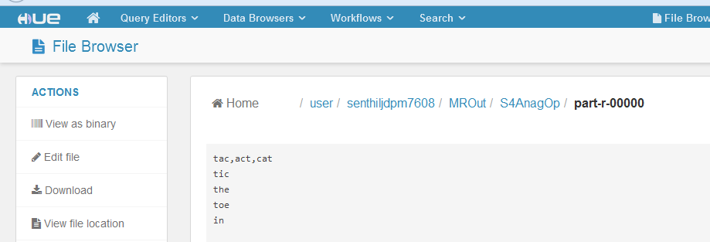

1. DNA 3a

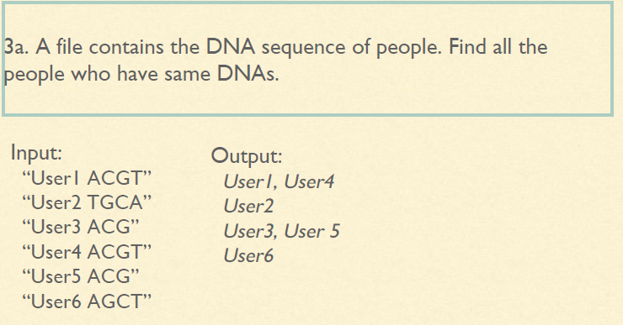

*Output:*

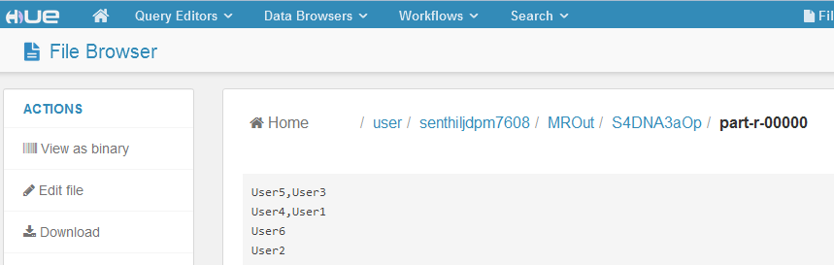

1. DNA 3b

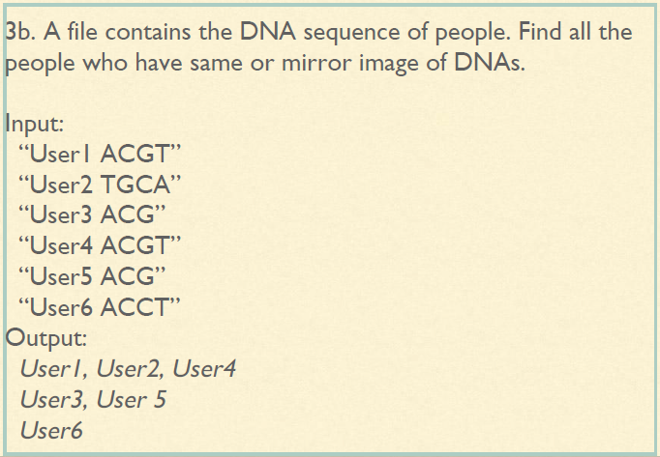

*Output:*

